**County of Santa Clara Registrar of Voters**

**Local Voters Rights Act**

**Local Voters Rights Act Tool Kit**

Thank you for partnering with the County of Santa Clara Registrar of Voters (ROV) Office to raise awareness regarding the local Voters Rights Act (VRA). This VRA tool kit contains information on Pre-Registration, Registering to Vote, information for Voters Formerly Incarcerated, Voters without a fixed residential address, and the Emergency Ballot Delivery Program for those that are not able to go to a Vote Center on Election Day.

The purpose of this tool kit is to provide information and outreach assistance regarding the local Voters’ Rights Act (VRA) to be adopted by the Board of Supervisors.

We invite you to join our efforts in spreading the word to our over one million voters and community about the options they have for registering to vote and voting in Santa Clara County. We invite you to play an active role in our democracy.

Please find promotional verbiage that we ask that you add to newsletters, e-mails, and other distributions. This kit also contains links to videos, sample social media verbiage, and additional helpful information.

**Pre-Registration**

The County of Santa Clara is one of the top 10 counties in California for pre-registration efforts. We have very active youth who are eligible to pre-register to vote at age 16 or 17 and will be automatically registered to vote once they turn 18 years of age! In 2020, we had nearly 7,000 youths pre-registered to vote; most of which turned 18 right before the November 2020 Election which allowed them to participate.

We invite you to share this information with youth and their parents. We have sample graphics included in Appendix A.

**Sample verbiage:**

*Did you know that anyone can pre-register to vote at 16 or 17 years of age? This means once you turn 18, you are automatically registered to vote. Preregister to vote online at* [*www.registertovote.ca.gov*](http://www.registertovote.ca.gov) *or call (866) 430-VOTE [8683] to request a voter registration card today!​*

In addition to the sample verbiage, we also have “How to” Video’s on our YouTube channel.

**Voters Formerly Incarcerated**

The Registrar of Voters is partnering with the County’s Probation Department and the Office of Reentry Services to create a partnership to deliver written and virtual materials to educate and inform those engaged in the re-entry process of their voting rights. Those efforts have begun and will continue throughout the summer of 2021. The Registrar of Voters also plans to engage in similar efforts with the youth in Juvenile Hall and the William F. James Ranch, as well as through a partnership with Bill Wilson Center.

We invite you to share the sample graphics included in Appendix B.

**Sample verbiage:**

*Did you know that if you are on probation or if you were formerly incarcerated you are now eligible to register and vote? If you have a criminal conviction, you may still be eligible to vote:* [www.sccvote.org/voters\_formerly\_incarcerated](http://www.sccvote.org/voters_formerly_incarcerated) *or you can go directly to* [*www.registertovote.ca.gov*](http://www.registertovote.ca.gov) *to register online.*

Instructions on how to complete the Voter Registration form, Voting Inmate Guide, and Who Can or Cannot Register to Vote can all be found on our website at:

[www.sccvote.org/voters\_formerly\_incarcerated](http://www.sccvote.org/voters_formerly_incarcerated)

In addition to the sample verbiage, we also have a video on our YouTube channel to assist with **Voter Registration in Santa Clara County Jails**. The video will also be available in other languages.

**Emergency Ballot Delivery Program**

The Emergency Ballot Delivery Program is designed for voters who are hospitalized, incarcerated, are in nursing homes, or are unable to retrieve their ballots in person. The program allows voters to request a ballot up to seven days before Election day to be mailed to them, or delivered to them by the hospital, correctional facility, or nursing home within the seven days immediately before Election day.

**Sample verbiage:**

*Are you unable to retrieve your ballot in person? The Emergency Ballot Delivery Program is available to assist you. An Emergency Ballot Delivery Application is available on our website at:*

[*https://www.sccgov.org/sites/rov/VBM/Pages/Emergency-Ballot-Delivery-Program.aspx*](https://www.sccgov.org/sites/rov/VBM/Pages/Emergency-Ballot-Delivery-Program.aspx)

We invite you to share the sample graphics included in Appendix B.

Here is a link to the packet for this program information:

<https://www.sccgov.org/sites/rov/VBM/Pages/Emergency-Ballot-Delivery-Program.aspx>

In addition to the sample verbiage you can send to your constituents, we also have a series of “How to” Video’s on our YouTube channel.

**Outreach to Voters without a fixed residential address**

For those voters that do not have a fixed residential address, the Registrar of Voters has information and resources available on how to vote while not living at a permanent residential address. Information can be found at:

[www.sccgov.org/sites/rov/Register/SpecialCircumstances/Pages/I-Do-Not-Have-a-Fixed-Address.aspx](http://www.sccgov.org/sites/rov/Register/SpecialCircumstances/Pages/I-Do-Not-Have-a-Fixed-Address.aspx)

The Registrar of Voters will also ensure that information is included in materials created for these voters who utilize social services provided by partner agencies throughout the County, including the Office of Supportive Housing and the Valley Homeless Healthcare Program.

Resources for voters:

Valley Homeless Healthcare Program  
2101 Alexian Dr. Suite D

San Jose, CA 95116

Valley Health Center at Home First Shelter

2011 Little Orchard St

San Jose, CA 95125  
Phone: (408) 885-5000 · TTY: (408) 971-4068

**“How to” Videos**

The Registrar of Voters has created several videos to share with our partners, constituents, employees, and staff. Videos are now available in Spanish, Chinese, Tagalog, Korean, Japanese, Khmer, Vietnamese, Hindi, Punjabi, Tamil, Nepali, Gujarati, and Telugu​.

Our videos are available on our YouTube channel: [www.youtube.com/sccvote](http://www.youtube.com/sccvote), and available upon request at (408) 282-3008.

The videos include the following:

* [How to Register to Vote](https://www.youtube.com/watch?v=5tZlFy8FrFk" \t "_blank)
* [How to Vote by Mail​](https://www.youtube.com/watch?v=WqVTE2e77Bc)
* [How to Vote in Person at a Vote Center](https://www.youtube.com/watch?v=Xu6i_fKRLK0)
* [How to Vote a Remote Access Vote by Mail Ballot (RAVBM)](https://www.youtube.com/watch?v=yriJm-DFLio)
* [How to Vote if you are a Military or Overseas Voter](https://youtu.be/gMQBZHOBfAU)

**Social Media**

Follow us on your social media accounts. The Registrar of Voters has an account on Facebook, Instagram, Twitter, YouTube and Next Door.

Here are some best practices for social media posts:

1. Mention Registrar of Voters in your post @sccvote
2. Tag your friends and partners to increase interactions. Feel free to tag us @sccvote and we will retweet your post, share, or link to your post.
3. Direct voters to our website to get more information [www.sccvote.org/vra](http://www.sccvote.org/vra)





**Calendar of Outreach Events**

**July 2021**

7/20 Outreach - West Evergreen Park

7/21 Outreach - Chris Hotts Park

7/22 Outreach - Welch Park

7/27 Outreach - Meadowfair Park

7/28 Outreach - Hillview Park

7/29 Outreach - Solari Park

7/30 Farmer’s Market 10-2\*

**August 2021**

8/2 Outreach - Watson Park

8/3 Outreach - Emma Prusch Park

8/5 Outreach - Starbird Park

8/6 Outreach - Farmer’s Market\*

8/9 Outreach - Solari Park

8/11 Outreach - Aborn Park

8/12 Outreach - Bellvue Park

8/17 Outreach - Vista Reach Park

8/19 Outreach - Flickinger Park

8/20 Outreach - Farmer’s Market\*

8/23 Outreach - Mayfair Park

8/24 Meeting - Language Accessibility Advisory Committee (LAAC)

8/25 Outreach - Plata Arroyo Park

8/26 Meeting - Voting Accessibility Advisory Committee (VAAC)

8/26 Outreach - De Anza Park

8/28-29 Outreach – [Silicon Valley Pride](https://www.svpride.com/)

All park outreach events are in conjunction with Viva Parks and will be held on the respective dates from 6:00 p.m. – 8:30 p.m. More information can be found on their website at:

<https://www.sanjoseca.gov/home/showpublisheddocument/74198>

\*Farmers Market will be held in the SOFA District – South First Street between San Salvador and William Streets every Friday until December 17 from 10 a.m.-2 p.m. These are in conjunction with sjdowntown.com

**Calendar of Local Voters Rights Act Feedback Forums**

Feedback Forums are open meetings to allow voters and community members the opportunity to provide feedback, foster civic engagement, and to get involved with voter participation in Santa Clara County. Democracy works when all voices are heard.

The feedback forums will be held in all languages as listed below. Please feel free to use our social media graphics to share this information with your community. Please go to [www.sccvote.org/vra](http://www.sccvote.org/vra) for the zoom link for each scheduled meeting.

Feedback Forum Dates

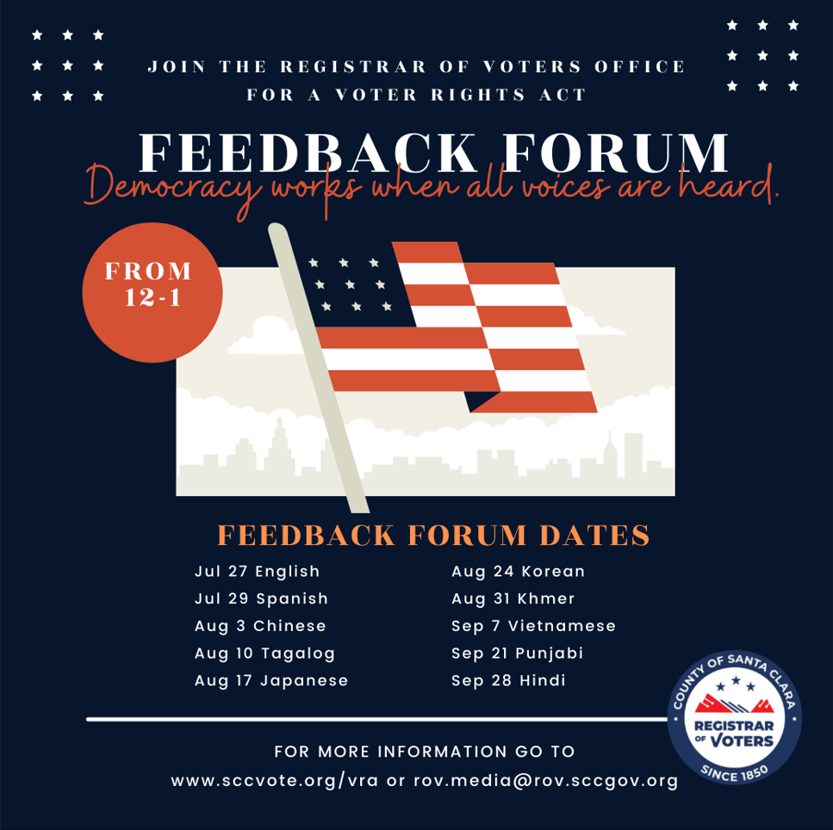

Jul 27 English

Jul 29 Spanish

Aug 3 Chinese

Aug 10 Tagalog

Aug 17 Japanese

Aug 24 Korean

Aug 31 Khmer

Sep 7 Vietnamese

Sep 21 Punjabi

Sep 28 Hindi

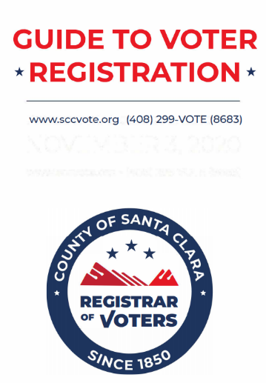**Voter Registration Pocket Guide**

Please go to: [Voter Registration Pocket Guide](https://sccvote.sccgov.org/sites/g/files/exjcpb1106/files/documents/Voter%20Registration%20Pocket%20Guide.pdf) to download and print copies of our Voter Registration Pocket Guide.

**Voting While Incarcerated**

Please go to: [www.sccvote.org/vra](http://www.sccvote.org/vra) to download the Voting While Incarcerated information chart.

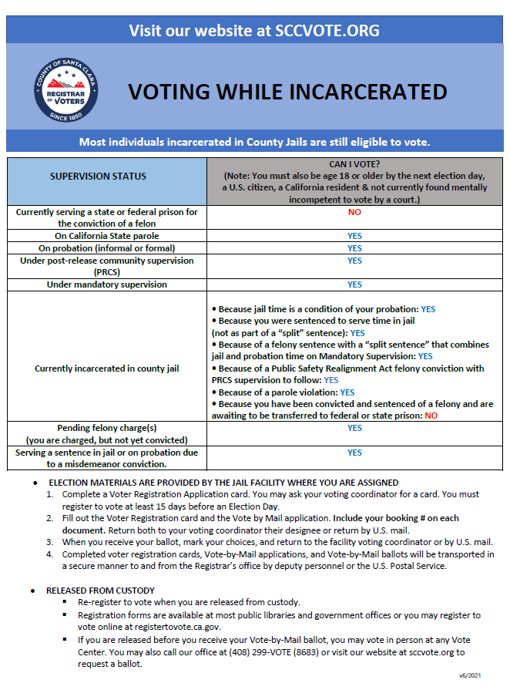

**APPENDIX A**

**Graphics and Social Media Posts for Use**

**Pre-Registration**

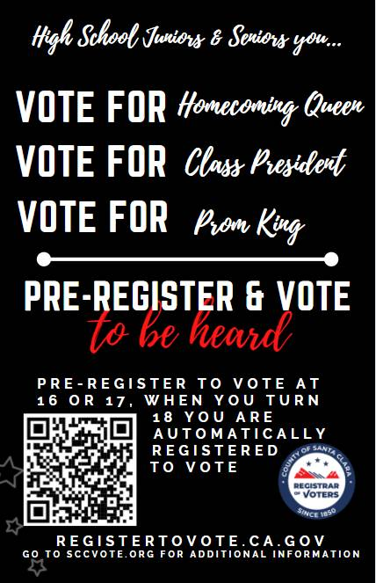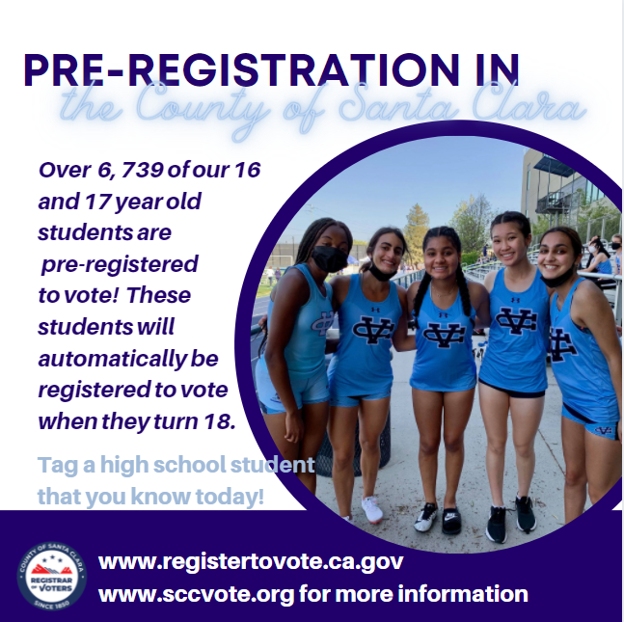

**APPENDIX B**

**Graphics and Social Media Posts for Use**

**Formerly Incarcerated**

****

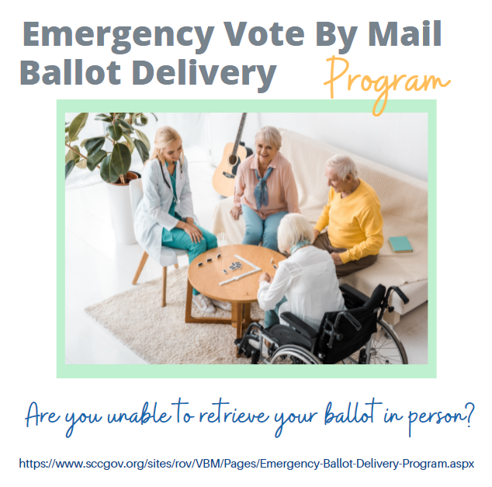**Emergency Ballot Delivery Program**

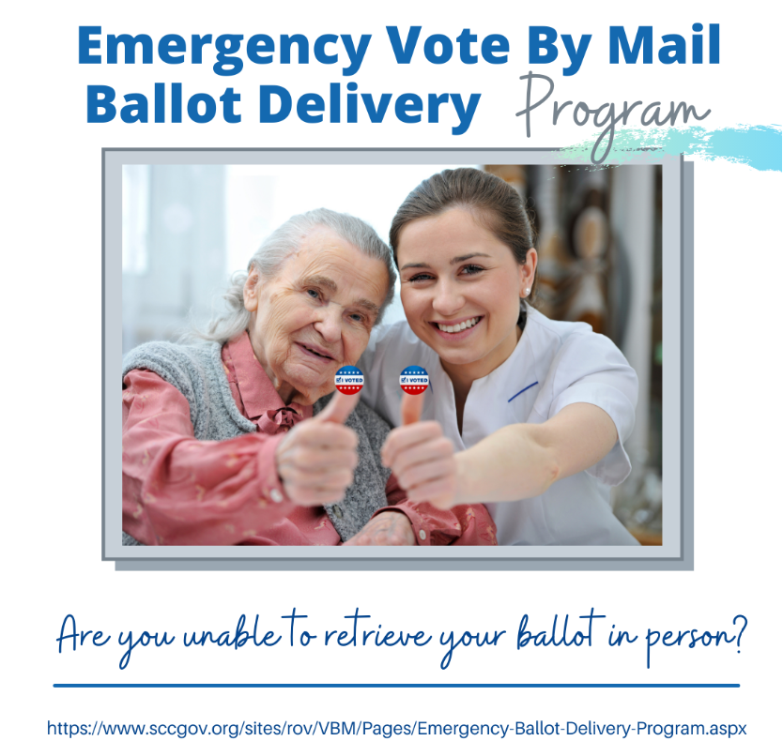**Contact us today:**

County of Santa Clara Registrar of Voters

Public and Legislative Affairs Division

1555 Berger Drive, Building 2

San Jose, CA 95112

Media Line: (408) 282-3008

Media e-mail: [rov.media@rov.sccgov.org](mailto:rov.media@rov.sccgov.org)

Website: www.sccvote.org/vra